**"Java Program for Weekly Temperatures"**

Kianté Hall

CSC320: Programming I

Dr. Whitfield

12 September 2024

**Pseudocode**

1. Initialize ArrayLists:
   1. Create two ArrayLists: one for days of the week and one for temperatures.
2. Prompt User Input:
   1. Ask the user to enter the day of the week or “week” to see temperatures for all days.
3. Store Data:
   1. For each day of the week, prompt the user to input the average temperature.
   2. Store the day and temperature in respective ArrayLists.
4. Display Data:
   1. If the user inputs a day, display the temperature for that specific day.
   2. If the user inputs “week”, display the temperature for each day and the weekly average temperature.
5. Calculate Weekly Average:
   1. Sum the temperatures and divide by the number of days to get the average.
6. Handle User Input:
7. Use a loop to continuously prompt the user until they choose to exit.

**Java Application**

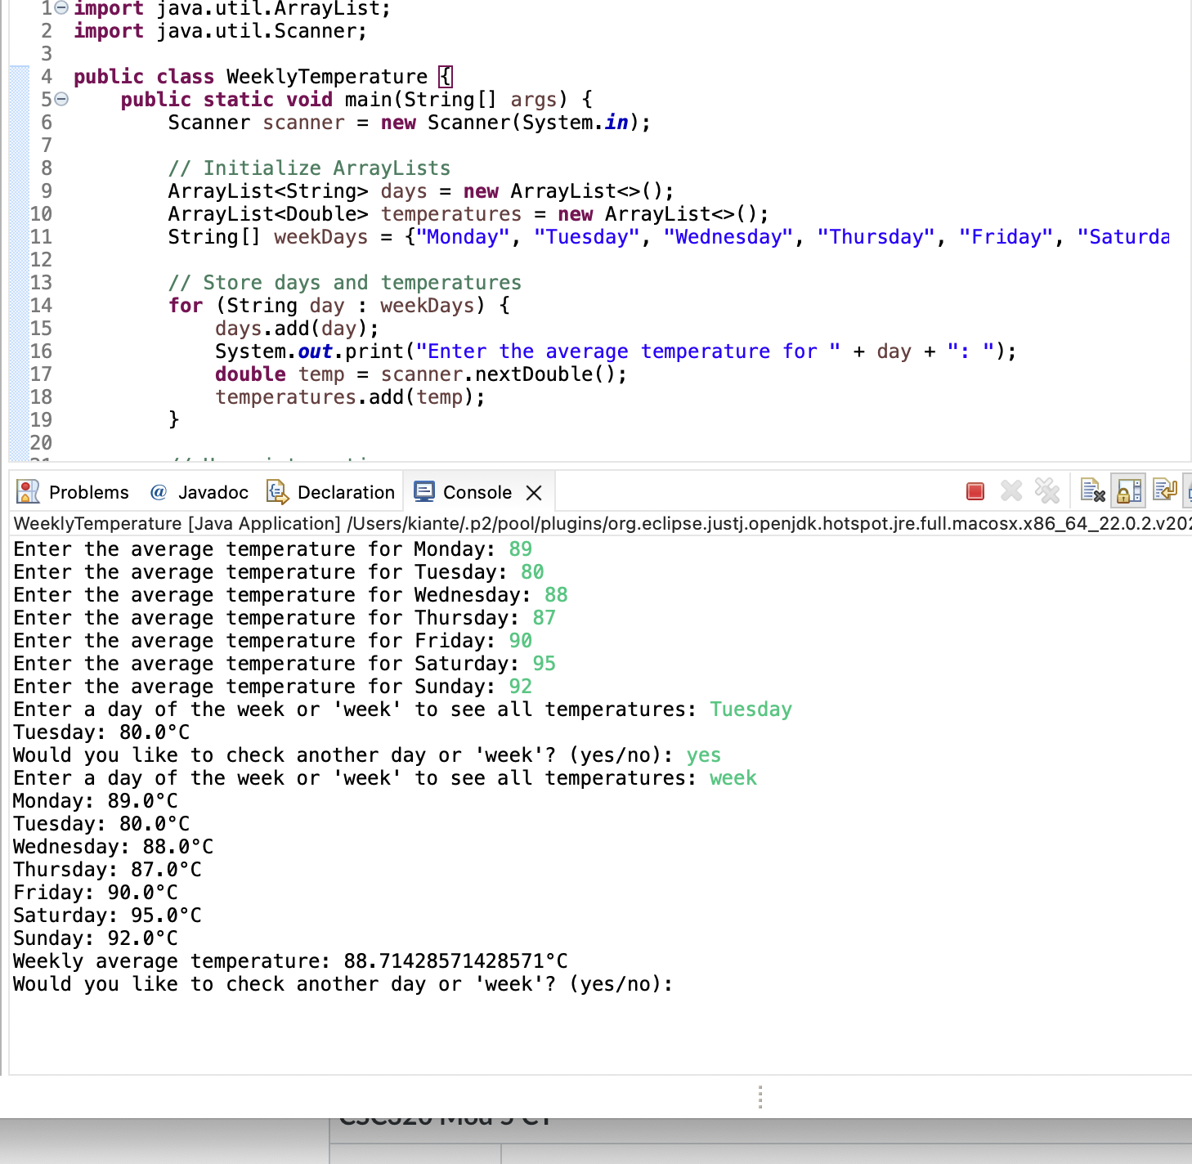

**Git Repository**